EXPERIMENT – 1.1
NAME – SUMANSHU JINDAL | UID – 24BCS11091
BRANCH – BE – CSE | SECTION/GROUP – 24BCS_APP-707A
SEMESTER – 5th | DATE OF PERFORMANCE – 8/9/2026
SUBJECT NAME – COMPETITIVE CODING | SUBJECT CODE – 24CSP – 305

Aim – To efficiently increment a large integer represented as digits by one using array manipulation techniques.
Objectives
- Understand efficient array manipulation techniques for arithmetic operations.
- Handle carry propagation across digits correctly and efficiently.
- Analyze time and space complexity of the implemented algorithm.
- Test solutions using normal, boundary, and edge cases.
Theory
A large integer can be represented as an array where each element stores one digit. To increment it, traversal begins from the least significant digit. If the digit is less than nine, it is incremented directly. Otherwise, it becomes zero and carry propagates leftward. If all digits are nine, one is prepended.
IMPLEMENTATION/INPUT CODE
#include <iostream>
#include <vector>
using namespace std;

vector<int> plusOne(vector<int>& digits) {
for (int i = digits.size() - 1; i >= 0; --i) {
if (digits[i] < 9) {
++digits[i];
return digits;
}
digits[i] = 0;
}

digits.insert(digits.begin(), 1);
return digits;
}

int main() {
int n;
cin >> n;

vector<int> digits(n);
for (int &digit : digits)
cin >> digit;

vector<int> result = plusOne(digits);

for (int digit : result)
cout << digit << " ";

return 0;
}
OUTPUT
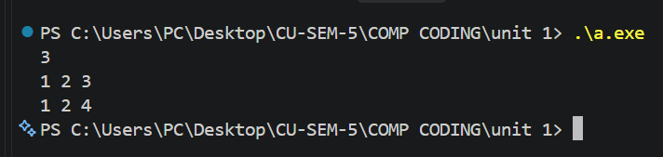
Learning Outcomes
- Understand representation of large integers using digit arrays.
- Implement carry propagation efficiently during arithmetic operations.
- Apply reverse traversal for processing least significant digits.
- Analyze algorithmic time and auxiliary space complexity accurately.
- Validate algorithms through boundary cases and representative test inputs.

